**Task Analysis**

Analysis and Design of User Interfaces (SEG3125)  
**Project Phase: 2**

Prepared For:  
Professor Fadi Malek

In accordance to the requirements of:

SEG3125 Spring/Summer 2018

Prepared By:

Mahyar Gorji (8135109)

Nicolas Paré (7084451)

Parastoo Saharkhiz (8697886)

University of Ottawa

Faculty of Engineering

July 8th, 2018

**Table of contents**

**Interaction Styles** **3**

**Conceptual Design** **3**

Central Concept 3

**User Requirements** **4**

Use Case Diagram 4

**Design Objectives and Constraints** **5**

**User Object Model** **6**

**User Task Model** **6**

**User Interface Model** **8**

**Evaluation** **8**

**Physical Design** **9**

Technologies 9

Programming Languages and Libraries 9

Development Environment 9

Project Management 9

Project Deployment 9

**Color Selection** **10**

General GUI Colors 10

UglierYou Colors 10

**Icons** **11**

**GUI Components** **11**

**Storyboard** **12**

Individual Screens 13

# Interaction Styles

The GUI of the website is unlike most modern websites, in that the site content is not paginated. All content and functionality is displayed on one main page, and different areas of the website are accessible simply by scrolling up or down. This provides a level of simplicity for the user, in that the possibility of getting lost in pages when using the site is non-existent.

There is also a navigation bar that is always present at the top of the screen to help guide users to where they would like to go on the site. This works collaboratively with the scrolling content design of our website, and users will have the option to work with whatever they feel most comfortable with.   
All links on the navigation bar navigate to the respective div tag’s id that corresponds to the content the user is looking for.

Buttons on the site are not standard buttons built with <button> tags. These buttons are built with <input> tags to preserve the ability to style the buttons with images that one might see on more high-end websites. This is the case for buttons on the customization area of the page, as well as the checkout page.

We also designed the site to be mobile-first, and responsive for every possible viewport. We realize that today’s users are not always browsing the internet or doing their shopping through a laptop or desktop computer, where the monitor’s viewport is large and readily available. We achieved this by using the bootstrap framework, and believe that it will benefit users browsing our site through their mobile device or tablet, and provide an equal or better experience for those doing so, compared to a laptop/desktop user.

# Conceptual Design

## Central Concept

At its core, *UglierYou* is a website about user expression. The website was designed at its core to be extremely easy to access, in its current iteration it is predominantly a one-page website, that is sleek, and responsive to multiple screen sizes. It is a website that focuses on selling shirts, which are lively, exciting and sometimes surprising in order to engage the user.

For the users:

The website will enable users to pick out the shirts they would like, through a variety of ways. This was done in order to allow the user to access the apparel that best matches their personal style. Some may prefer to go with what’s trendy and choose a popular shirt, while others may want to create their own shirt and then compare their creation with their friends.

# User Requirements

*Shoppers:*

The role of the shopper is to browse the website, view different shirt designs, choose a shirt they like and be able to select different colours and sizes. The shopper can also design their shirt using the “personalize” section on the website. To do so, they can upload a photo of the design, see how the design will look on the shirt, choose the colour and size of the shirt and proceed with checkout.

## Use Case Diagram

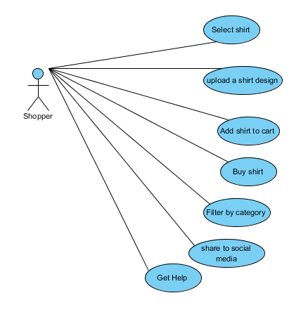

# Design Objectives and Constraints

This section contains the objectives and constraints for “An Uglier You”. They have been categorized based on their priority and their importance to the user. The objectives have been categorized into high priority, necessary-to-function objectives, and low-priority, nice-to-have objectives that only improve quality of life upon use.

The following bullets note our objectives by order of importance.

High Priority

* Add shirt to cart
* Buy shirt
* Select shirts
* Upload a shirt design

Low Priority

* Filter by category
* Share to social media

Buying and selecting shirts are crucial to the design and success of our product, as without it, an e-commerce site for selling articles of clothing is meaningless, and the equivalent of online “window-shopping”.

Uploading a shirt design is also crucial, as this design element is what distinguishes our e-commerce site from others, in that we provide functionality to upload a t-shirt design you like, a pattern from a selection palette that is provided to the user.

Filtering results and sharing to social media are lower in priority, as the user can still obtain the product they are expecting from the site, thus fulfilling the site’s purpose. These two options in the low priority category are placed where they are as adding these design elements in will better quality of life for a user using the site, but have work-arounds if not implemented and are therefore not crucial to the success of this site.

# User Object Model

We omitted a User Object Model in this project, given our core use of HTML/CSS/Bootstrap. Initially we had planned to have a lot more backend functionality, but after receiving feedback in our Phase 0 plan, to the effect of. “You have a good plan, but make sure to put the largest effort on the UI design and not on complexity.” We took this to mean, focus on how the customer would experience the product, and interact with it, rather than building out many custom features. This in turn, allowed us to pivot our efforts.

We do have certain backend functionality we may add, but they are still a low priority for us in terms of goals. If we do end up having time to add more functionality/complexity, they will most likely come in the form of tried and tested 3rd party tool integrations that can work with our website through Javascript scripts.

# User Task Model

|  |  |  |
| --- | --- | --- |
| **Task** | **Prerequisite** | **Details** |
| Select shirt | - | 1. Go to the website 2. Scroll to the “Cool shirt” or “Popular shirt” section 3. Select on a desired t-shirt to view |
| Upload a shirt design | Have a logo or image to upload | 1. Go to the website 2. Scroll to the “Personalize” section 3. Click on the upload button, select a design 4. View the design on the shirt |
| Add shirt to cart | - | 1. Go to the website 2. Select the shirt 3. Click on the “Add to cart” button |
| Buy shirt | Have at least a shirt added to Shopping Cart | 1. Go to website 2. Select the Shopping cart tab 3. Click on the Checkout button 4. Enter required information and proceed with purchase |
| Get Help | Go to create your own shirt section | 1. Go to the “Build your own” section 2. Select help 3. Ready the help |

# User Interface Model

The user interface model was built in our prototype for Uglier You. For more information on the user interface model, consult the Physical Design section.

# Evaluation

|  |  |  |
| --- | --- | --- |
| **Objective** | **Positive Feedback** | **Negative Feedback** |
| Customize a shirt | * Nice feature on the website | * Could come off as overwhelming with the amount of customization |
| Sort shirts by category | * Would be really nice to a larger selection, and see them by prices | * No way to force the list of shirts to update with new content, only reorganize |
| Upload a photo for custom Shirt | * Felt really fun | * Would have liked to see clearer guidance on how it would show up on the shirt |
| See customer reviews | * Makes a lot of sense to have, would help users feel comfortable trusting a new company | * Can limit the number of showcasing customer reviews, since there is no direct way for them to post comments |
| Access website on iPad/Phone | * I liked that I didn’t have to scroll like crazy, and that the website fit properly on my phone and my computer | * N/A |

# Physical Design

## **Technologies**

### Programming Languages and Libraries

At its core, this project is web-based. We’ve used HTML, CSS for the core layout and UI of the website, and in addition layered it with Bootstrap in order to comply with having a fully responsive website. Bootstrap was also chosen to help reduce the burden of long development time on writing a lot of CSS, and instead we were able to leverage prior knowledge of Bootstrap use to, be more efficient with our total development time. Javascript was used in certain instances to add either 3rd party functionality, or improve the user experience through effects like, smooth scrolling, etc.

(Note: Bootstrap version. 3.3.7 was used instead of 4.0, based on it having a larger pool of documentation and guidance, as well as better matching the experience of our team)

### Development Environment

The IDE we used for this project was *Brackets*. We chose brackets for a few reasons: we have prior experience with it which will help us make better use of our time. In addition, given we are heavily focusing on the UI, and it is web based, we can make use of how effective Brackets is with its various addons, and features to write inline CSS quickly while in the HTML file for example.

### Project Management

A project space was created at <https://github.com/UglyShirtTrio/UglierYou>. This space helped us work concurrently on the project, and manage version control effectively. In addition, it made accessing certain shared files easier.

### Project Deployment

This was an area where *Brackets* was a great help. It has a live-viewing feature that allows you to visually see how your website looks; and in addition, as you write and make edits, you can see in real-time how the webpage would look. This development process has effectively made “deployment”, not much of a risk since we are aware of what it would look like if we were to deploy the code. For this project however, we may not end up deploying the website to a server and on it’s own URL, and instead rather demonstrate it offline during the class.

# Color Selection

## General GUI Colors

Our interface at its core is about the products, or the shirts, being presented. That’s why we focused on Blues, to allow the products to speak loudly from themselves without being held back by a loud color scheme. Yet, the Blues with certain accent colors are able to be used to point attention to important areas of interest for users to be drawn to. Most colors used in the page however, were intentionally chosen to be more muted than normal to again, draw attention to the products themselves and to further draw the user in, and not the website background.

## UglierYou Colors

The colors below give an idea of our current color scheme, but these have changed many times already, and may not reflect exactly what I final product looks like.

Navigation Bar/Guiding Color

* Colors used:  #002040
* Uses a darker powerful color in order to keep the user engaged in the page, while also creating clear contrasts with the more muted colors on the page to add flair to the website.

Primary Colors

* Colors used:  #00CCFF,  #AEEEF5,  #D9EBFF
* As mentioned above, the primary colors are very muted, this is to be able to create an engaging flow for the user, while also putting the focus of the website on the product instead of on a loud background style for the website.

Accent Colors

* Colors used:  #FFA100
* This color was chosen because it is almost an exact complementary color to the above #00CCFF. Although complimentary colors can be quite strong used improperly given they are by design, almost the exact opposite color on the CMYK color wheel. We feel this can be used tastefully in our website given how muted every other color is, which will allow us to take advantage of the strength that such a contrast can provide.

# Icons

In our website icons were used sparingly to avoid a bloated UI but mainly, given that icons can be confusing for first-time users. Given that our user-base will at least initially be primarily first-time users, heavy use of icons may be disadvantageous. That being said, we will be using a Shopping Cart icon given this is a consistently used icon amongst most websites, that will help users from different language and cultural backgrounds be able to use the website effectively.

# GUI Components

|  |  |
| --- | --- |
| **Component** | **Usage Description** |
| Label | Main form of communication with the users through text. |
| Button | Used to allow users to add a shirt to their cart, upload images, insert text, get help, etc. |
| Checkbox | A component that lets the user choose their shirt colour |
| Drop Down List | Used to display to the user a full list of choices for their shirt size |
| Navigation bar | Allows users to be taken straight to the section of the website they want to visit. |
| Text area box | used for allowing users to send a customized message to us for help. Also used to allow user to place a custom text on their shirt |

# Storyboard

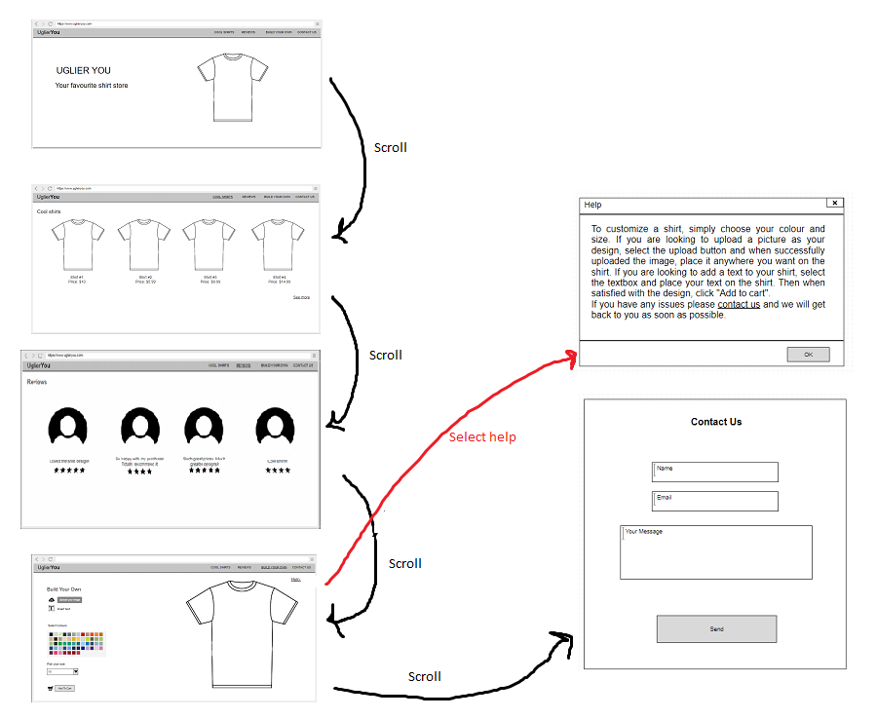

## Individual Screens

